MXB262 - Case Studie

Critical Analysis Report
1.0: Visualisation descriptions

1.1: Visualisation 1
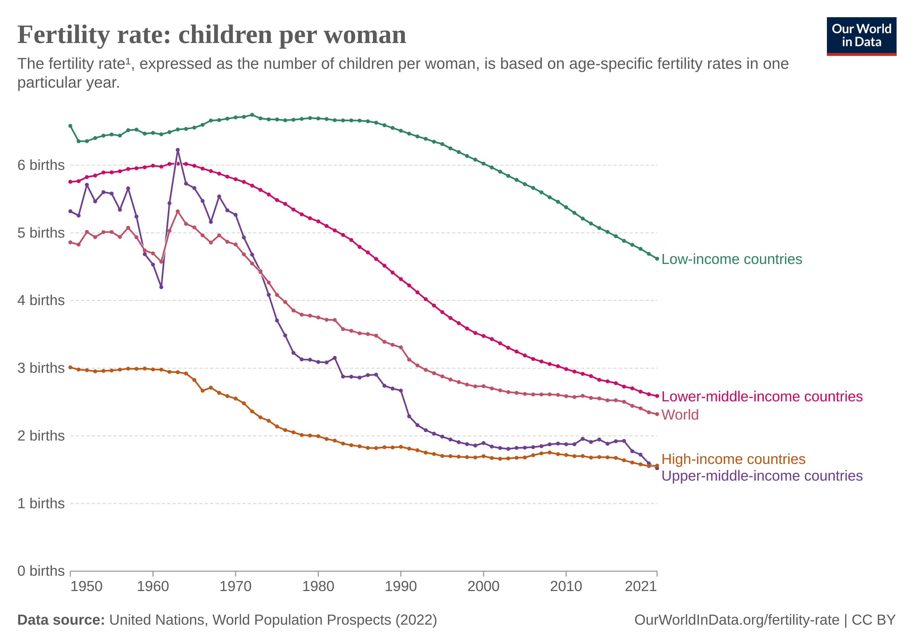
Figuer 1: https://ourworldindata.org/fertility-rate
The above graph is a line graph shwoing the Fertility Rate over the years 1950 to 2021 in Children Per Women with different lines representing countries in difrrent income brackets form Low income to High income.

1.2: Visualisation 1
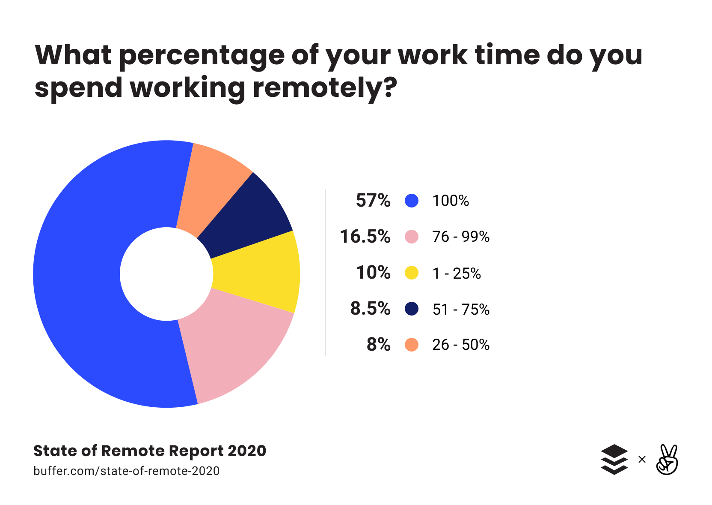
Figuer 2: https://buffer.com/state-of-remote-work/2020
The above graph is a Pie Graph showing percentage of work time spent working remotely with different colors reprecenting percentages of working remote ranging from 100% to 1%,

2.0 Audience and action suitability
2.1: Visualisation 1

The fertility rate graph doesn’t didplay a strong action the user should take but rather tries to inform the user in best way possible, which it does very well. As well this graph displays no spicific Target Audience, this graph is not a so called fun graph with a “cool” apperence that is ment for a billbord but a piece of information that is ment to display the inforamtion with no aggender behind it. This would most likely be used in reports and reasurch papers, more buissness focused work. The line type graph works well for the timesires data and shwoing different icome brakets, as the graph is clear and easy to read and follow the inforamtion.

2.2: Visualisation 2

The Work Remotely graph is a very simple graph showing a single statistic, the percentage of work done remotlely, interms of showing this stat it does an ok job. The graph is slightly confusing to follow with the legend being agubly in the wrong order when paired with the chart. The Pie type chart used is the correclt way to go when it comes to these percentages however its not effective when paierd with the legend and the graph itsself is becomes unnessacery when nested with the legend.

3.0 Critical evaluation of structure
3.1: Visualisation 1

When looking at the Firtlity Rate graph it looks very infomative but on closer inpection its missing data that would provide a far clearer picture and more informative graph. Such data includes what consitutes a “Low-income” Country or any of the income brackets, and what coutries fall into what income bracket? The graph being a line graph with multiple colors of lines is a very effective way of showing this timeseires data of multiple data groups. The plot structure is clear with none of the graph being hard to read or interprate, the legend being color coded and aligned to the lines makes it exreamly clear with no confusion. The line colors for “World” and “High Income Coutries could be confused but they do not overlap nor come close together, so this is not an issue with the aligned legend to the lines. Overall the graph is well layedout with no confusion on any of the data trying to be presented, apart from the small amount of missing information that would help with context of the graphs data, this graph is excelent.

3.2: Visualisation 2

When looking at the Work Remotely graph, its a very simple graph however it doesn’t display the information effectivly. The graph and legend do not work togther, if the Pie plot was removed and only the legend was present no data would be lost which is an inifective use of the plot. The Pie Plot Type is however the best for this type of percentage data. The legend is also in wrong order, the legend is in order from highest percentage to lowerst of people in each group, this is inefective as that graph is ment to represent this data not the legend and to have the legend centered around this data make the legend confusing to read. The plot colors also don’t match the order of the legend this makes it difficultt to find the information quickly. Overall the graph is layed out incorreclty making data difficult to make out at a quick glance.

4.0 Critical evaluation of aesthetic choices
4.1: Visualisation 1

The Firtlity Rate graph’s aesthetics are clean ansd well thoughtout, the data is not cramped and well spread out, the only coloring is to represent the different groupings and this is very effective. No unesscierry space used or taken up by non-important information

4.2: Visualisation 2
The Work remotely graph’s aesthetics are not great, empty space top the right of the graph and the wrong information is bold in the legend. The colors however do make it easy to distiguis the different groupings. The plot its self also has lots of space inside the segments going unused.

5.0 Recommendations
5.1: Visualisation 1
For the Firtlity Rate graph the 1st improvement would be the additional infromation about the groupings on how they are defined and maybe what coutries are in them, this would make the graph have more context and be more useable. The 2nd rercomendation would be vertical lines from top to bottom indicating each decade as it could be hard to determin what year the data is at, at the top of the plot. A 3rd recomendatio would be to have more distinct colors for rach grouping line, this is becase as is the gra0ph was to be extrapolated oput the lines could cross and get closer together and this could lead to groupings getting confused with eachother.

5.2: Visualisation 2
For the Work remotely graph the 1st recomandation would be to better use the space, place the Pie percentages around or inside the Pie Graph itself, this would make the plot useful and have a perpose. 2nd Improvement is to reorder the legend and plot as it should be ordered in tearms of work percentage this is also how the plot should be ordered clockwise, this is for better readability. 3rd Recomendation is to layout, to the right of the graph there is a lot of empty space and to balance the graph out it, and make it more plreasing to look as the graph should be cented and cropped to reduce empty space.

